VATSALYA INTERNATIONAL SCHOOL, BORSAD
ONLINE TEACHING PROGRAMME FOR PRE-PRIMARY
(2020-2021)
CLASS : NURSERY DATE :04/06/2020
SUBJECT: ENGLISH WORKSHEET: 01
EX.1 Oral Activity – A TO Z
* Parents Pathshala (Role of Parents)
- Make the child to see the video and let them speak the letters accordingly
- When child speak the letters A to Z parents are requested to observe whether the child is following correct sequence or not .
EX.2 FLASH CARD READING
*Parents Pathshala
Let the child read the letter by using index finger and say.........
A FOR APPLE |  | B FOR BALL | C FOR CAT
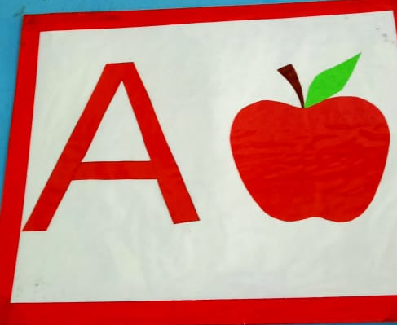 |  | 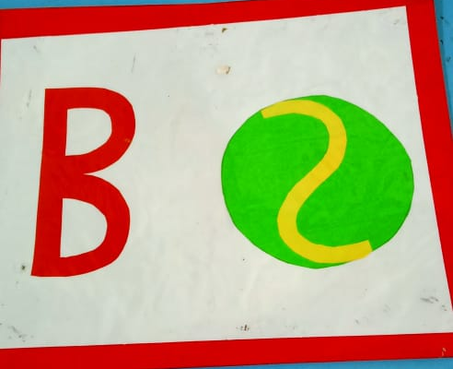 | 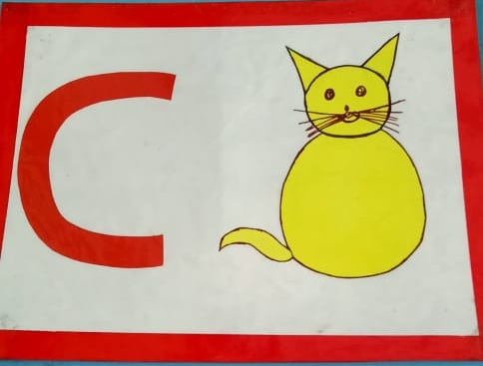
EX.3 FILL THE COLOUR IN THE BELOW GIVEN LETTERS .
A | A
PARENT | CHILD


